Global You-tube Statistics

Introduction :

The “Global YouTube Statistics” project is designed to analyze and visualize YouTube channel performance on a global scale using real-world data. YouTube has become one of the most influential digital platforms, with millions of creators producing content across different categories and countries. This project focuses on understanding how channels grow in terms of subscribers, generate video views, and earn revenue over time. By analyzing metrics such as total subscribers, total views, content categories, country-wise distribution, and earnings, the project provides a comprehensive overview of the YouTube ecosystem.
The dataset is processed and analyzed using Tableau to create interactive dashboards that simplify complex data into meaningful insights. Key performance indicators (KPIs) such as total YouTube channels, total subscribers, total views, and average yearly earnings help summarize the overall platform performance. Visualizations like bar charts, treemaps, donut charts, scatter plots, and maps are used to compare top channels, identify popular content categories, and analyze regional trends.
This project helps content creators understand which strategies lead to higher engagement and revenue, while businesses and marketers can identify high-performing categories and regions for collaboration. Overall, the Global YouTube Statistics dashboard serves as a powerful decision-support tool that enables data-driven insights into audience behavior, content performance, and monetization trends across the global YouTube platform.
Scenario 1: Content Creator Strategy Optimization

Content creators can use the insights from the Global YouTube Statistics dashboard to understand which content categories attract the highest number of subscribers and views. By analyzing charts such as Subscribers by Content Category, Views vs Subscribers, and Top Channels by Subscribers, creators can identify successful content trends and benchmark their performance against top-performing channels. These insights help creators optimize their content strategy, improve audience engagement, and focus on producing videos that generate higher views and earnings.

Scenario 2: Brand Marketing and Influencer Selection

Brands and digital marketing agencies can leverage this dashboard to identify influential YouTube channels and regions with high audience reach. Visualizations such as Country-wise Subscribers, Country-wise Earnings Distribution, and Top Channels by Subscribers help marketers select the right influencers for brand collaborations and advertising campaigns. By understanding regional popularity and monetization patterns, brands can make data-driven decisions to maximize marketing ROI and target the most impactful creators.
Scenario 3: Platform Growth and Monetization Analysis

Business analysts and platform strategists can use the Global YouTube Statistics project to study global trends in YouTube growth and monetization. KPIs such as total subscribers, total views, and average yearly earnings provide a high-level overview of platform performance, while deeper analysis using scatter plots and category-wise earnings helps identify revenue-driving segments. These insights support strategic planning, market expansion analysis, and policy decisions to enhance creator monetization and platform sustainability.
Technical Architecture:
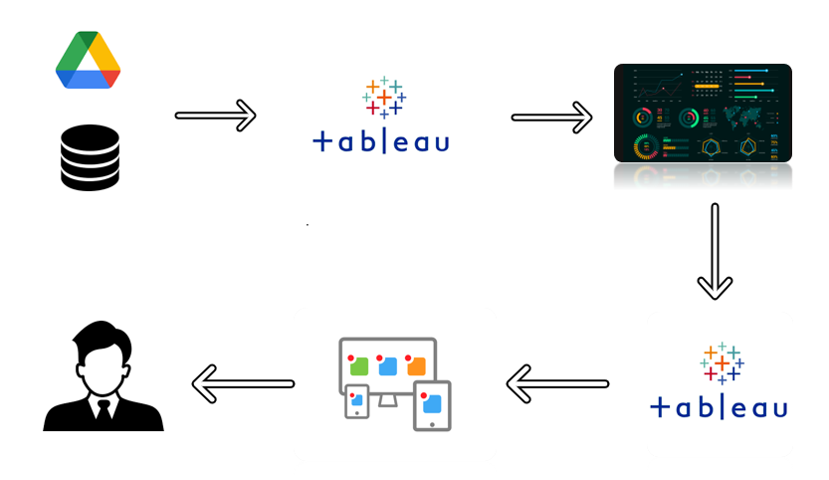

Project Flow
To accomplish this, we have to complete all the activities listed below,
- Define Problem / Problem Understanding
- Specify the business problem
- Business requirements
- Literature Survey
- Social or Business Impact.
- Data Collection & Extraction from Database
  - Collect the dataset,
  - Storing Data in DB
  - Perform SQL Operations
  - Connect DB with Tableau
- Data Preparation
- Prepare the Data for Visualization
- Data Visualizations
- No of Unique Visualizations
- Dashboard
  - Responsive and Design of Dashboard
- Story
  - No of Scenes of Story
- Performance Testing
  - Amount of Data Rendered to DB ‘
  - Utilization of Data Filters
  - No of Calculation Fields
  - No of Visualizations/ Graphs
- Web Integration
  - Dashboard and Story embed with UI With Flask
- Project Demonstration & Documentation
  - Record explanation Video for project end to end solution
  - Project Documentation-Step by step project development procedure

Milestone 1: Data Collection & Extraction from Database

Data collection is the process of gathering and measuring information on variables of interest, in an established systematic fashion that enables one to answer stated research questions, test hypotheses, and evaluate outcomes and generate insights from the data.

Activity 1: Collect the dataset

Please use the link to download the dataset: https://www.kaggle.com/datasets/adershkohli/global-you-tube-statistics

Activity 1.1: Understand the data

Data contains all the meta information regarding the columns described in the CSV files. we have provided 1 CSV file:
1. Global Youtube Statistics Data.csv
Column Description of the Dataset
- Abbreviation
- Category
- Channel Name
- Country
- Country Rank
- Created Month
- Created Year
- Gross tertiary education enrollment
- Population
- Subscribers For Last 30 Days
- Unemployment rate
- Urban Population
- Video Views For the Last 30 Days
- Youtuber
- Measure Names
- Channel Type Rank
- Created Date
- Engagement Rate
- Highest Monthly Earnings
- Highest Yearly Earnings
- Lowest Monthly Earnings
- Lowest Yearly Earnings
- Subscribers
- Uploads
- Latitude
- Longitude
- Measure Values

Activity 2: Storing Data in DB & Perform SQL Operations
Explanation video link:
Storing data.mp4
Activity 3: Connect DB with Tableau
Explanation video link:
Connecting DB.mp4

Milestone 2: Data Preparation

Activity 1: Prepare the Data for Visualization

Preparing the data for visualization involves cleaning the data to remove irrelevant or missing data, transforming the data into a format that can be easily visualized, exploring the data to identify patterns and trends, filtering the data to focus on specific subsets of data, preparing the data for visualization software, and ensuring the data is accurate and complete. This process helps to make the data easily understandable and ready for creating visualizations to gain insights into the performance and efficiency.

Milestone 3: Data Visualization

Data visualization is the process of representing data in graphical form to make information easy to understand and analyze. In the Global YouTube Statistics project, data visualization helps transform large and complex YouTube data into clear and meaningful insights. By using charts, graphs, and maps in Tableau, users can quickly identify trends, patterns, and outliers related to subscribers, views, earnings, countries, and content categories.

Activity 1: No of Unique Visualizations

In the Global Youtube Statistics Dataset, multiple unique visualizations were created using Tableau to analyze channel performance and audience behavior. The visualizations include KPI cards, bar charts, scatter plots, treemaps, donut charts, filled maps, and box plots. These visuals help compare top YouTube channels, analyze subscriber growth, understand content category popularity, and study earnings distribution across countries.
Overall, these visualizations provide a clear view of YouTube’s global reach, creator performance, and monetization trends, making the data more accessible and actionable for decision-making.

Activity 1.1: Total Youtube Channels

Explanation video link: Total Youtube Channels kpi-1.mp4
Activity 1.2: Total Subscribers
Explanation video link: Total Subscribers kpi-2.mp4
Activity 1.3: Total Views
Explanation video link: Total Views kpi-3.mp4
Activity 1.4: Average Yearly Earnings
Explanation video link: Avg Yearly Earnings kpi-4.mp4
Activity 1.5: Top 10 Channels by Subscribers
Explanation video link: Top 10 Channels by Subscribers.mp4
Activity 1.6: Country-wise Earnings Distribution
Explanation video link: Country-wise Earnings Distribution.mp4
Activity 1.7: Country-wise Subscribers Share
Explanation video link:
Country-wise Subscribers Share.mp4
Activity 1.8: Subscribers by Content Category
Explanation video link: Subscribers by Content category.mp4
Activity 1.9: Earnings Contribution by Category
Explanation video link: Earnings Contribution by Category.mp4
Activity 1.10: Top Subscribers vs Views
Explanation video link: Top Subscribers vs views.mp4

Milestone 4: Dashboard
A dashboard is a graphical user interface (GUI) that displays information and data in an organized, easy-to-read format. Dashboards are often used to provide real-time monitoring and analysis of data, and are typically designed for a specific purpose or use case. Dashboards can be used in a variety of settings, such as business, finance, manufacturing, healthcare, and many other industries. They can be used to track key performance indicators (KPIs), monitor performance metrics, and display data in the form of charts, graphs, and tables.
Activity :1- Responsive and Design of Dashboard
The responsiveness and design of the Global YouTube Statistics Dashboard play a crucial role in presenting insights clearly and effectively. A well-structured dashboard helps users quickly understand key metrics such as total subscribers, total views, earnings, top channels, and country-wise performance. The dashboard is designed with a clear layout, properly aligned KPI cards, readable charts, and consistent color themes to ensure better visual clarity and easy interpretation.
Responsiveness ensures that the dashboard adjusts smoothly across different screen sizes without affecting readability or layout. Interactive elements such as filters, tooltips, and hover actions allow users to explore channel performance, content categories, and monetization trends in more detail. Overall, the dashboard is designed to be user-friendly, visually appealing, and informative, enabling stakeholders to make data-driven decisions using YouTube performance insights.
Once the individual visualizations were created on separate worksheets in Tableau, they were combined into a single interactive dashboard to provide a complete and meaningful analytical view.
Explanation video link: Global Youtube Statistics Dashboard.mp4
https://public.tableau.com/views/Book389_17667515408510/Dashboard1?:language=en-US&publish=yes&:sid=&:redirect=auth&:display_count=n&:origin=viz_share_link

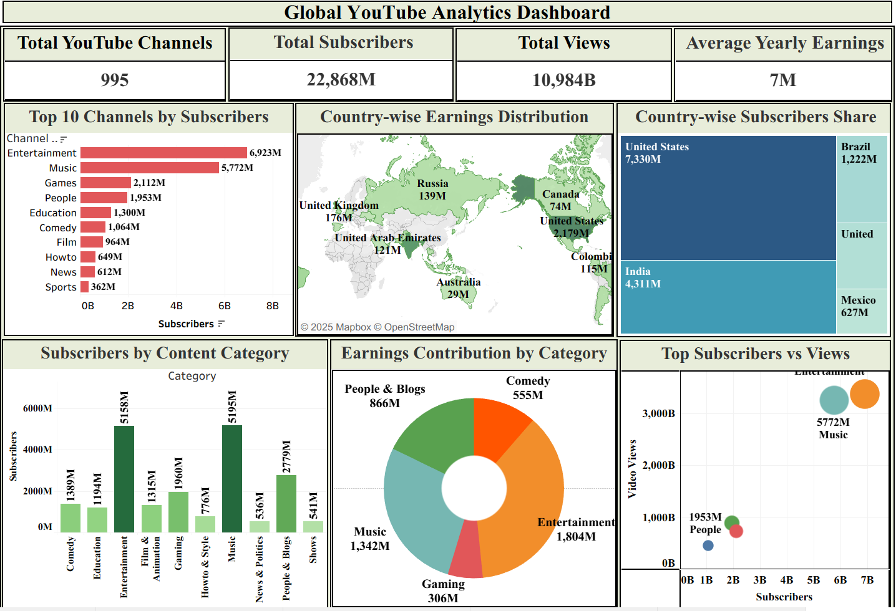

Milestone 5: Story
A data story is a way of presenting data and analysis in a narrative format, with the goal of making the information more engaging and easier to understand. A data story typically includes a clear introduction that sets the stage and explains the context for the data, a body that presents the data and analysis in a logical and systematic way, and a conclusion that summarizes the key findings and highlights their implications. Data stories can be told using a variety of mediums, such as reports, presentations, interactive visualizations, and videos.
Activity:1- No of Scenes of Story
The number of scenes in the storyboard for the Global YouTube Statistics project is designed based on the key insights that need to be communicated effectively. Each scene represents a specific stage of analysis and helps guide the user through the data in a logical and meaningful sequence. The storyboard breaks complex YouTube performance data into simple, easy-to-understand visual steps.
The story begins with an overview of global YouTube performance using KPI metrics, followed by scenes highlighting top channels, country-wise subscriber distribution, content category popularity, and earnings analysis. Additional scenes focus on engagement patterns, such as the relationship between subscribers and views, and monetization insights across regions. Overall, the storyboard ensures a smooth narrative flow, allowing users to clearly understand trends, comparisons, and key business insights derived from the Global YouTube Statistics dataset.
Explanation video link:
Storytelling.mp4
https://public.tableau.com/views/Book000_17668249973940/Story1?:language=en-US&publish=yes&:sid=&:redirect=auth&:display_count=n&:origin=viz_share_link

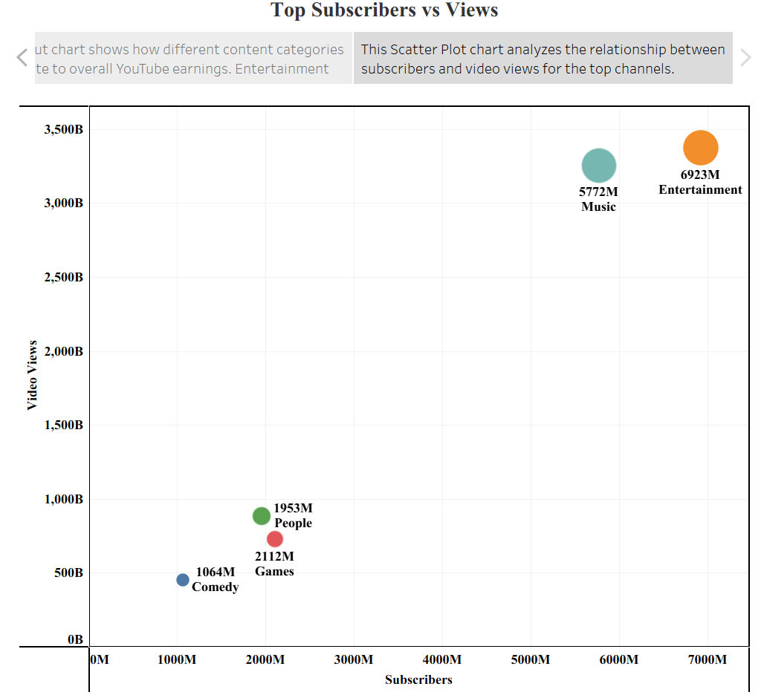

Milestone 6: Performance Testing

Activity 1: Amount of Data Rendered to DB

- The amount of data that is rendered to a database depends on the size of the dataset and the capacity of the database to store and retrieve data.

- Open the MySQL Workbench, go to the database then click to expand the tables,select the table and click on (i) button to get the information related to table such as column count,table rows etc.

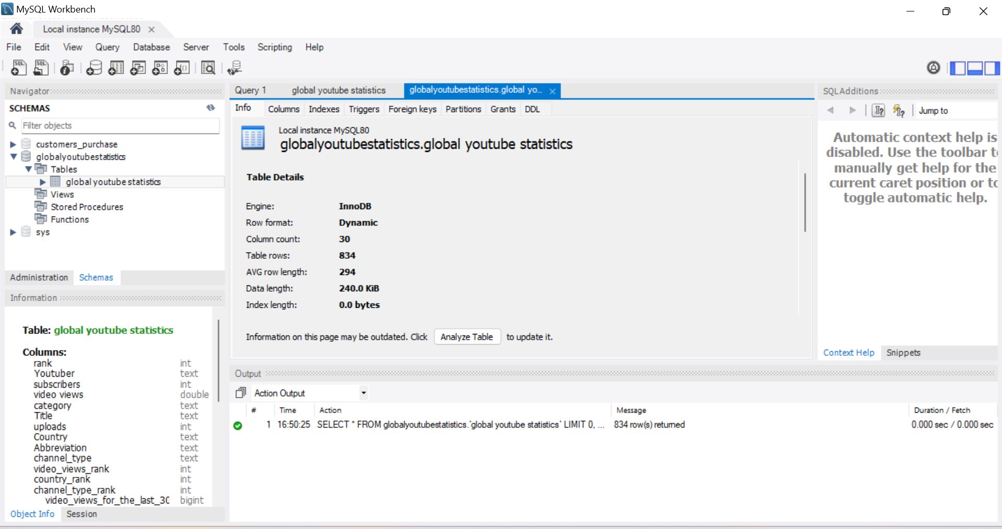

Activity 2: Utilization of Data Filters

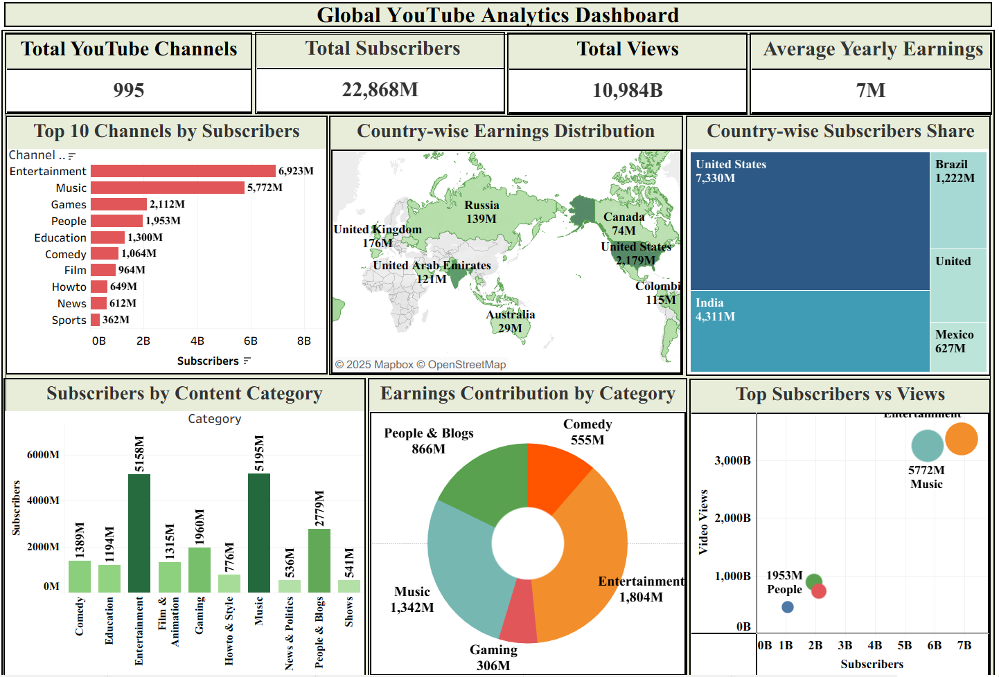

Activity 3: No of Calculation Fields

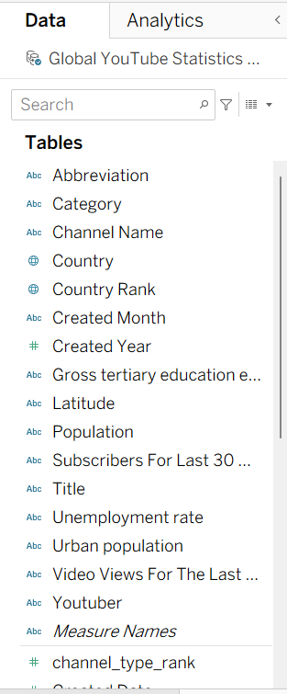

Activity 4: No of Visualizations/ Graphs

- Total Youtube Channels
- Total Subscribers
- Total Views
- Average Yearly Earnings
- Top 10 Channels by Subscribers
- Country-wise Earnings Distribution
- Country-wise Subscribers Share
- Subscribers by Content Category
- Earnings Contribution by Category
- Top Subscribers vs Views

Milestone 7: Web integration
Publishing helps us to track and monitor key performance metrics, to communicate results and progress. help a publisher stay informed, make better decisions, and communicate their performance to others.
Publishing dashboard and reports to tableau public
Step 1: Go to Dashboard/story, click on share button on the top ribbon

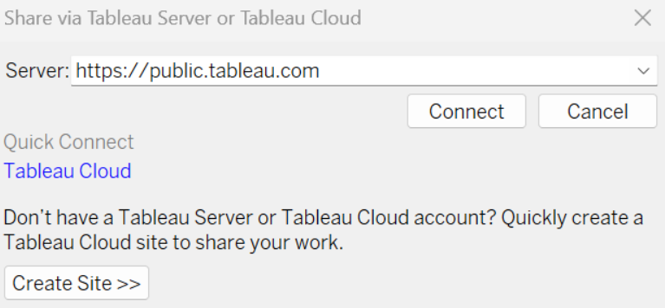
Give the server address of your tableau public account and click on connect.
Explanation Video: Dashboard, story publish.mp4

Step 2: Once you click on connect it will ask you for tableau public user name and password
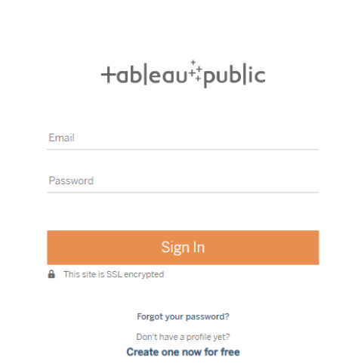

Once you login into your tableau public using the credentials, the particular visualization will be published into tableau public
Note: While publishing the visualization to the public, the respective sheet will get published when you click on share option.

Activity 1: Dashboard and Story embed with UI With Flask

Web Integration.mp4

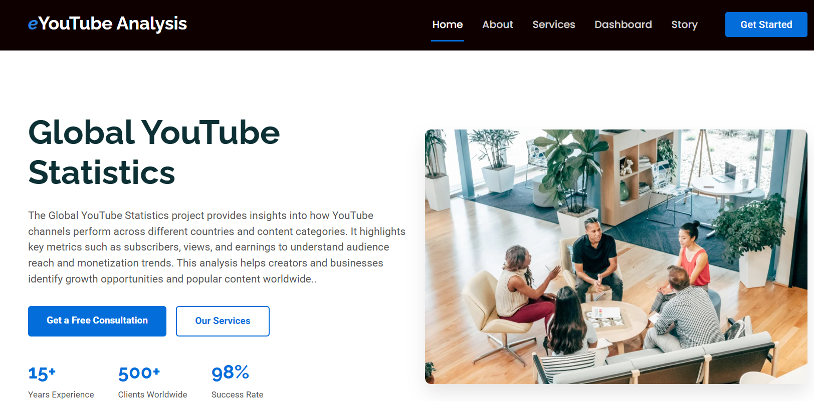

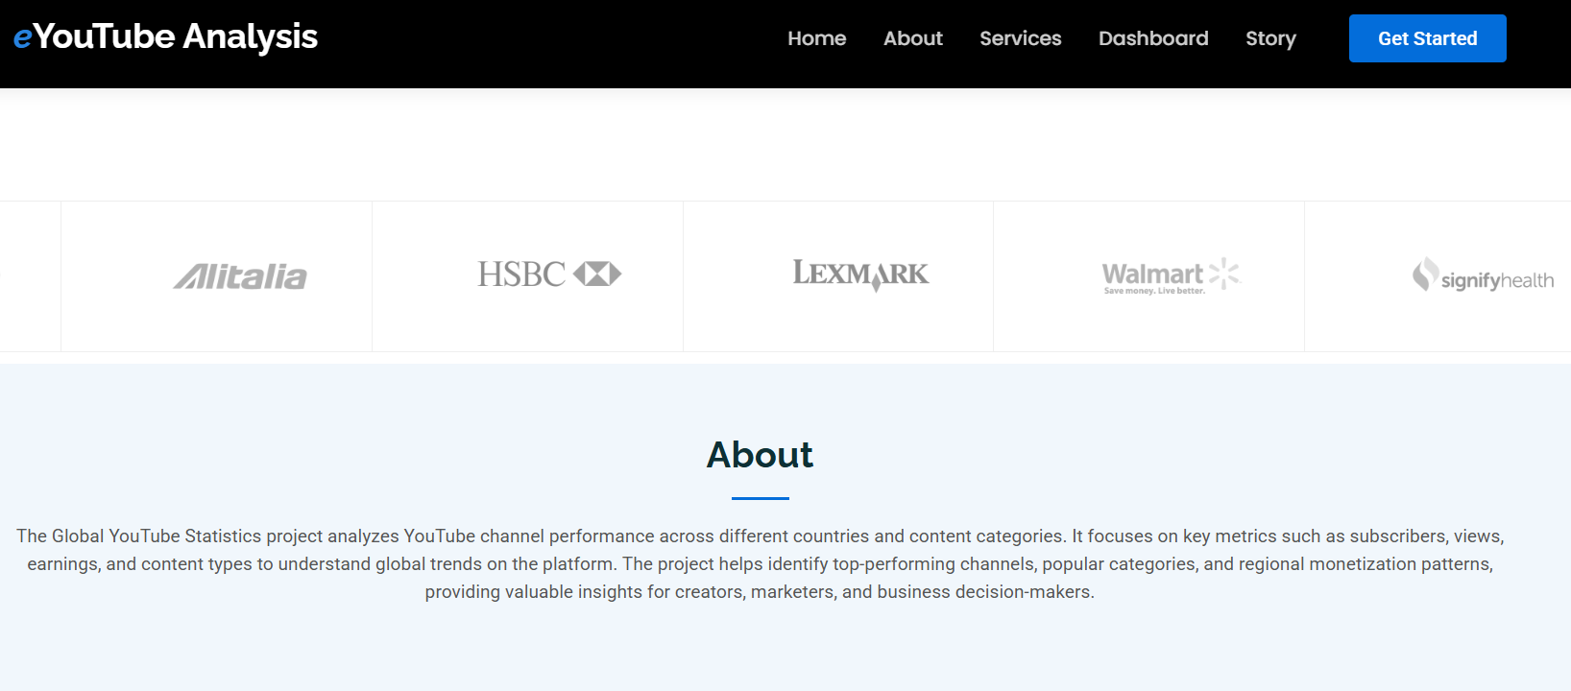

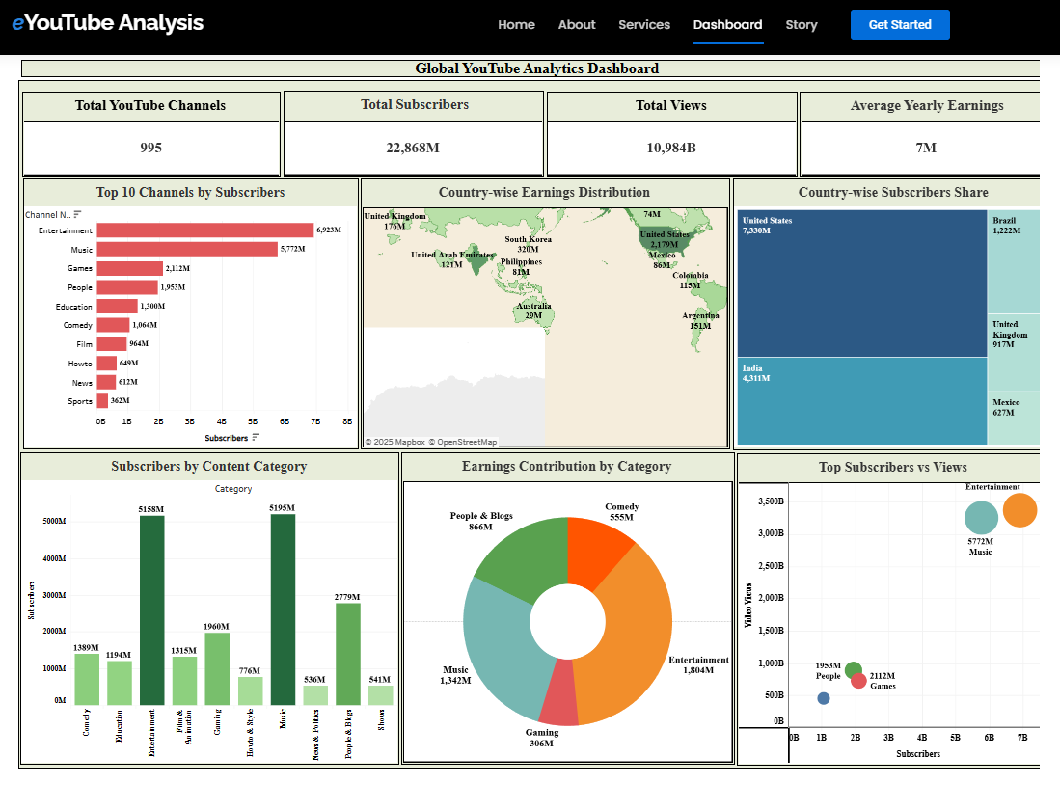

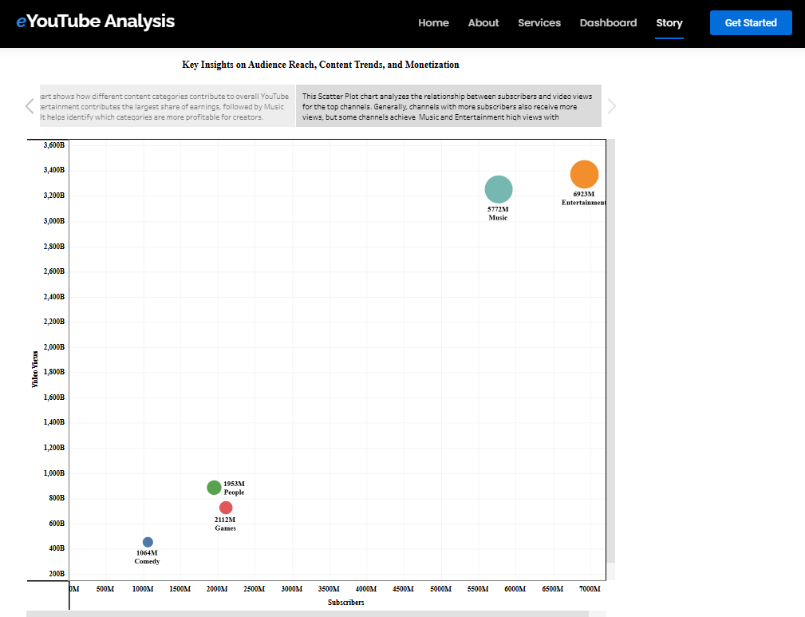

Milestone 8: Project Demonstration & Documentation
Below mentioned deliverables to be submitted along with other deliverables
Activity 1: - Record explanation Video for project end to end solution
Activity 2: - Project Documentation-Step by step project development procedure
Create document as per the template provided

